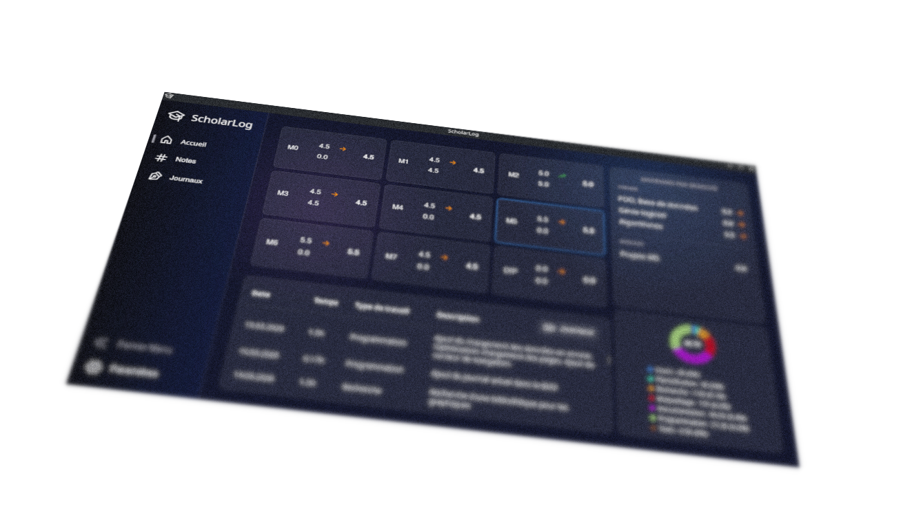
ScholarLog
M5 – User guide

Auteur :
Hofer Lukas
2nd year ES IT Technician

Module coordinators :
Choffat Lise
Claude Fahrni
Montavon Dominique


January-June 2026
Higher Technical School
Table of content
1. About ScholarLog 3
2. Minimum System Requirements and installation 4
2.1 System Requirements 4
2.2 No Installation 4
2.2 Installation (if you really want) 4
3. Menus Overview 5
3.1 Home Menu (Dashboard) 5
3.2 The Notes Menu (My Results) 7
3.3 The Journals Menu (My Journals) 9
3.4 The Settings Menu (Paramètres) 11
4. Average Calculation Logic 13
5. Limitations regarding attached PDF files 13
6. Data Backup and Security 14
7. Software License (GPLv3-only) 15

1. About ScholarLog
Welcome to ScholarLog ! This application was specifically designed for students (particularly technicians at the École Supérieure Technique) to simplify and centralize the tracking of their education. Say goodbye to complex spreadsheets and tedious manual calculations.
ScholarLog is a standalone tool that allows you to manage your academic journey intuitively within a modern, dark-mode interface. Here is what the application allows you to do :
- Grades Tracking and Automatic Calculations :
Enter your results and let the application automatically calculate your weighted averages by subject and by module.
- Work Log :
Keep an accurate track of the time spent on your various tasks (revisions, projects, documentation) using a built-in logbook. You can categorize your hours and visually display your investment through charts.
- Privacy and Autonomy :
The application works entirely offline. All your data is saved locally on your computer as a single file. You have full control over your data, without relying on a remote server.
- Cross-platform :
Whether you use Windows, macOS, or Linux, ScholarLog offers you the same seamless experience.

2. Minimum System Requirements and installation
ScholarLog is designed to be lightweight, cross-platform, and highly accessible. Because it is a standalone executable with all libraries and dependencies already included, there is no complex installation process.

2.1 System Requirements
- Operating System :
Compatible with Windows, macOS, and Linux.
- Permissions :
The file must have execution rights to run properly (e.g., allowing execution via the context menu on Windows, or using the chmod +x command on Linux/macOS).
- Internet Connection :
None required after the initial download. The application is completely standalone and works entirely offline.
- Storage :
500 MB of free storage space is recommended (to accommodate the application and user data).

2.2 No Installation
- Navigate to the project's GitHub page (github.com/Hoferlukaslh/ScholarLog/releases).
- Download the file that corresponds to your operating system from the Releases page.
- Simply open the downloaded file. No installation is required.
Note for macOS user ; How to start the app for the first time :
- On your Mac, choose the Apple menu  > System settings, then click "Privacy and Security"  in the sidebar. (You may need to scroll down the page.)
- Go to Security, then click Open.
- Click "Open anyway".
- This button displays for about an hour after you have tried to open the app.
- Enter your login password, then click OK.
Default: No automatic shortcuts in the device menu.

2.2 Installation (if you really want)
- Navigate to the project's GitHub page (github.com/Hoferlukaslh/ScholarLog/releases).
- Download the installer that corresponds to your operating system from the Releases page.
- Execute-it and follow the instructions. (linux DEB : sudo apt intall -y ./*.deb)
Advantage: Automatic addition of the application shortcut to the device menu.

3. Menus Overview

3.1 Home Menu (Dashboard)
The house icon in the sidebar takes you to the Home page. This is your main dashboard, designed to give you an immediate overview of your academic standing.
- Global View (Modules Grid) :
Upon opening, you will find all your modules (M0, M1, M5, DIP, etc.) displayed as cards. Each card directly shows your current average for that module, accompanied by a trend arrow (an upward green arrow for improvement, a downward red arrow for a decrease, or an orange arrow for a stable average).
- Detailed View (Clicking on a module) :
When you click on one of the modules (for example, M5), the interface dynamically adapts to show you detailed information related to that specific module. New panels will appear on the screen :
  - Averages by Subject (Right) :
This panel details your results subject by subject (Theory, Projects, etc.) within the selected module, again with their trend arrows.
  - Work Log Overview (Bottom) :
A table lists your latest work sessions for this module (Date, Time spent, Task type, and Description). A "Journals" button allows you to quickly switch to the full work log menu.
  - Distribution Chart (Bottom Right) :
A donut chart illustrates the distribution of your work time. It displays your total hours in the center, alongside a detailed legend showing the percentage of time spent on each category (Programming, Research, Prototyping, etc.).
- Display Customization (Resizing) :
The interface is entirely flexible. You can adjust the size of the different panels (the log, the chart, or the averages) according to your preferences. Simply click and drag the divider lines located between these elements to expand or shrink the areas of your choise.

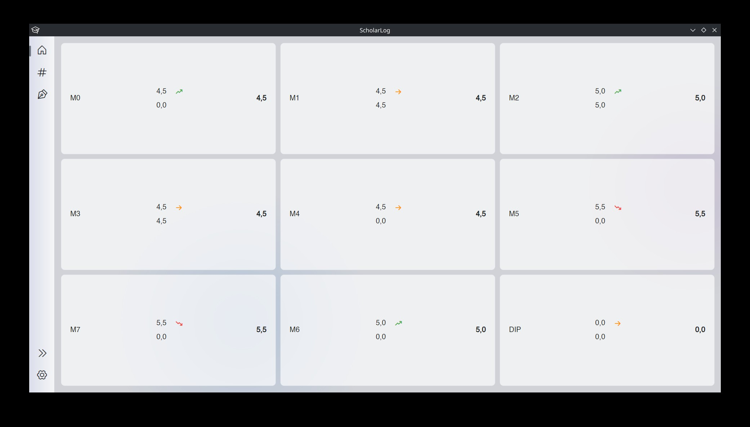
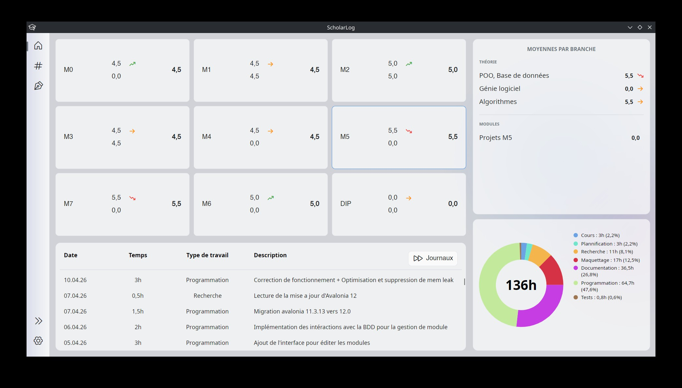

3.2 The Notes Menu (My Results)
The hash icon (#) in the sidebar gives you access to the "My Results" page. This is the central space dedicated to managing your assessments.
- Display Modes and Filters :
In the top right corner of the screen, two buttons allow you to change how your results are presented:
  - Liste (List) :
Displays all your grades as a single, global list.
  - Par module (By module) :
Allows you to select a specific module via a dropdown menu (e.g., M0 - Connaissances fondamentales). Your grades are then visually grouped by subject (English, Mathematics, etc.), making them much easier to read.
- Add, Edit, or Delete a Grade :
To add a result, click the + button. A window opens asking you to fill in the module, the subject, the assessment title, the date, and the grade obtained (on a scale of 1 to 6).
  - For each grade in your list, the "Action" column on the right provides a Pencil icon to edit the information, and a Trash bin icon to delete the entry.
- Attach and View PDFs (Preview) :
This is one of ScholarLog's key features! When creating or modifying a grade, you have the option to attach a PDF document (for example, a scan of your graded exam).
  - If a document is linked to a grade, a file icon appears in the "Action" column.
  - Clicking on this icon opens a built-in PDF reader directly within the application. You can zoom in, navigate between pages, and even download the file to your computer using the "Télécharger" (Download) button.
- Export Your Results :
The "Exporter" (Export) button in the top right corner allows you to extract your academic data. The application generates an export that you can choose to format as MD (Markdown), CSV (ideal for spreadsheets like Excel), or JSON. You can then copy the generated text with a single click or save it to a file.

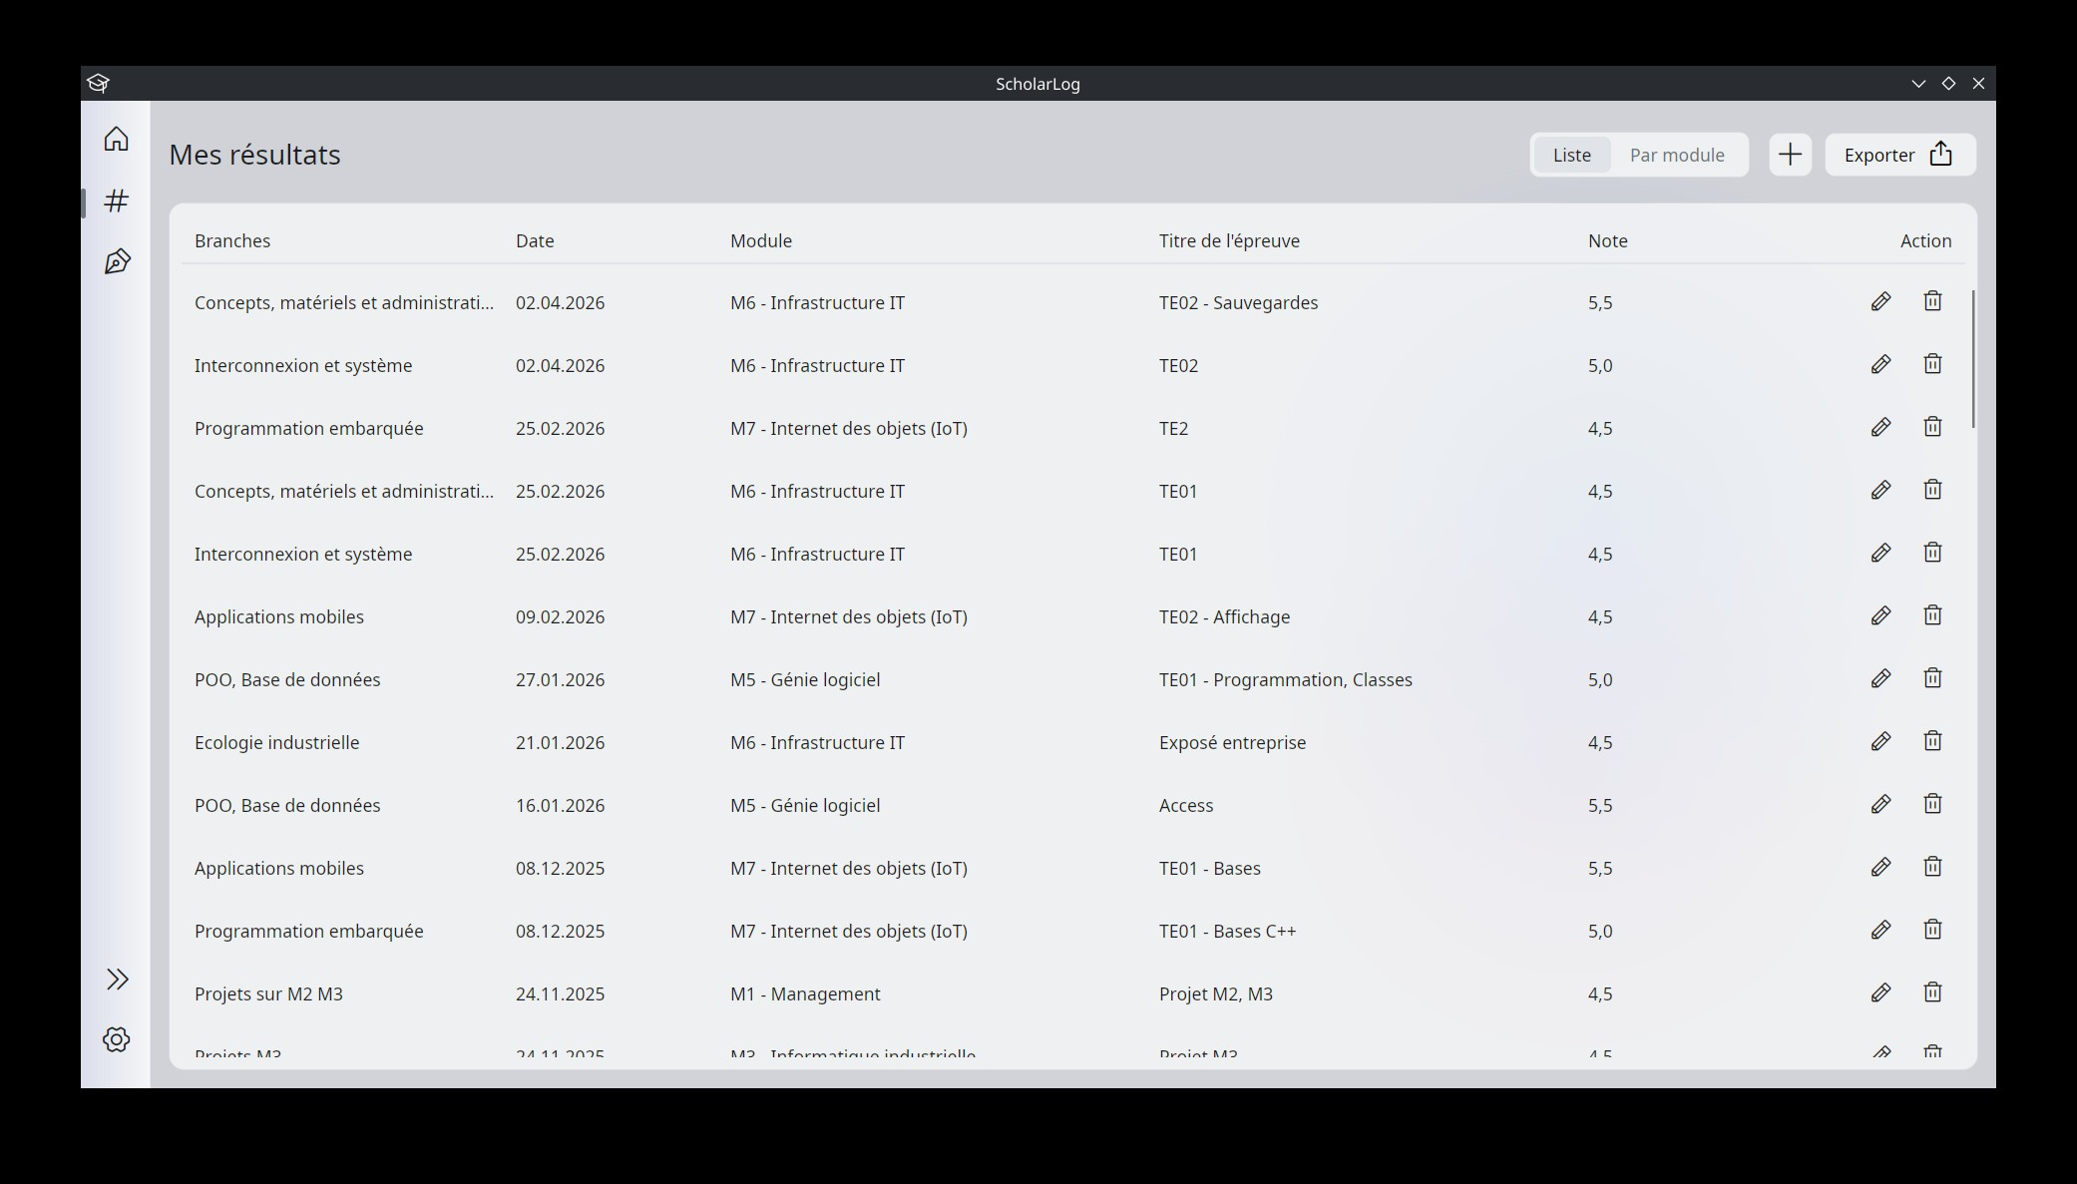
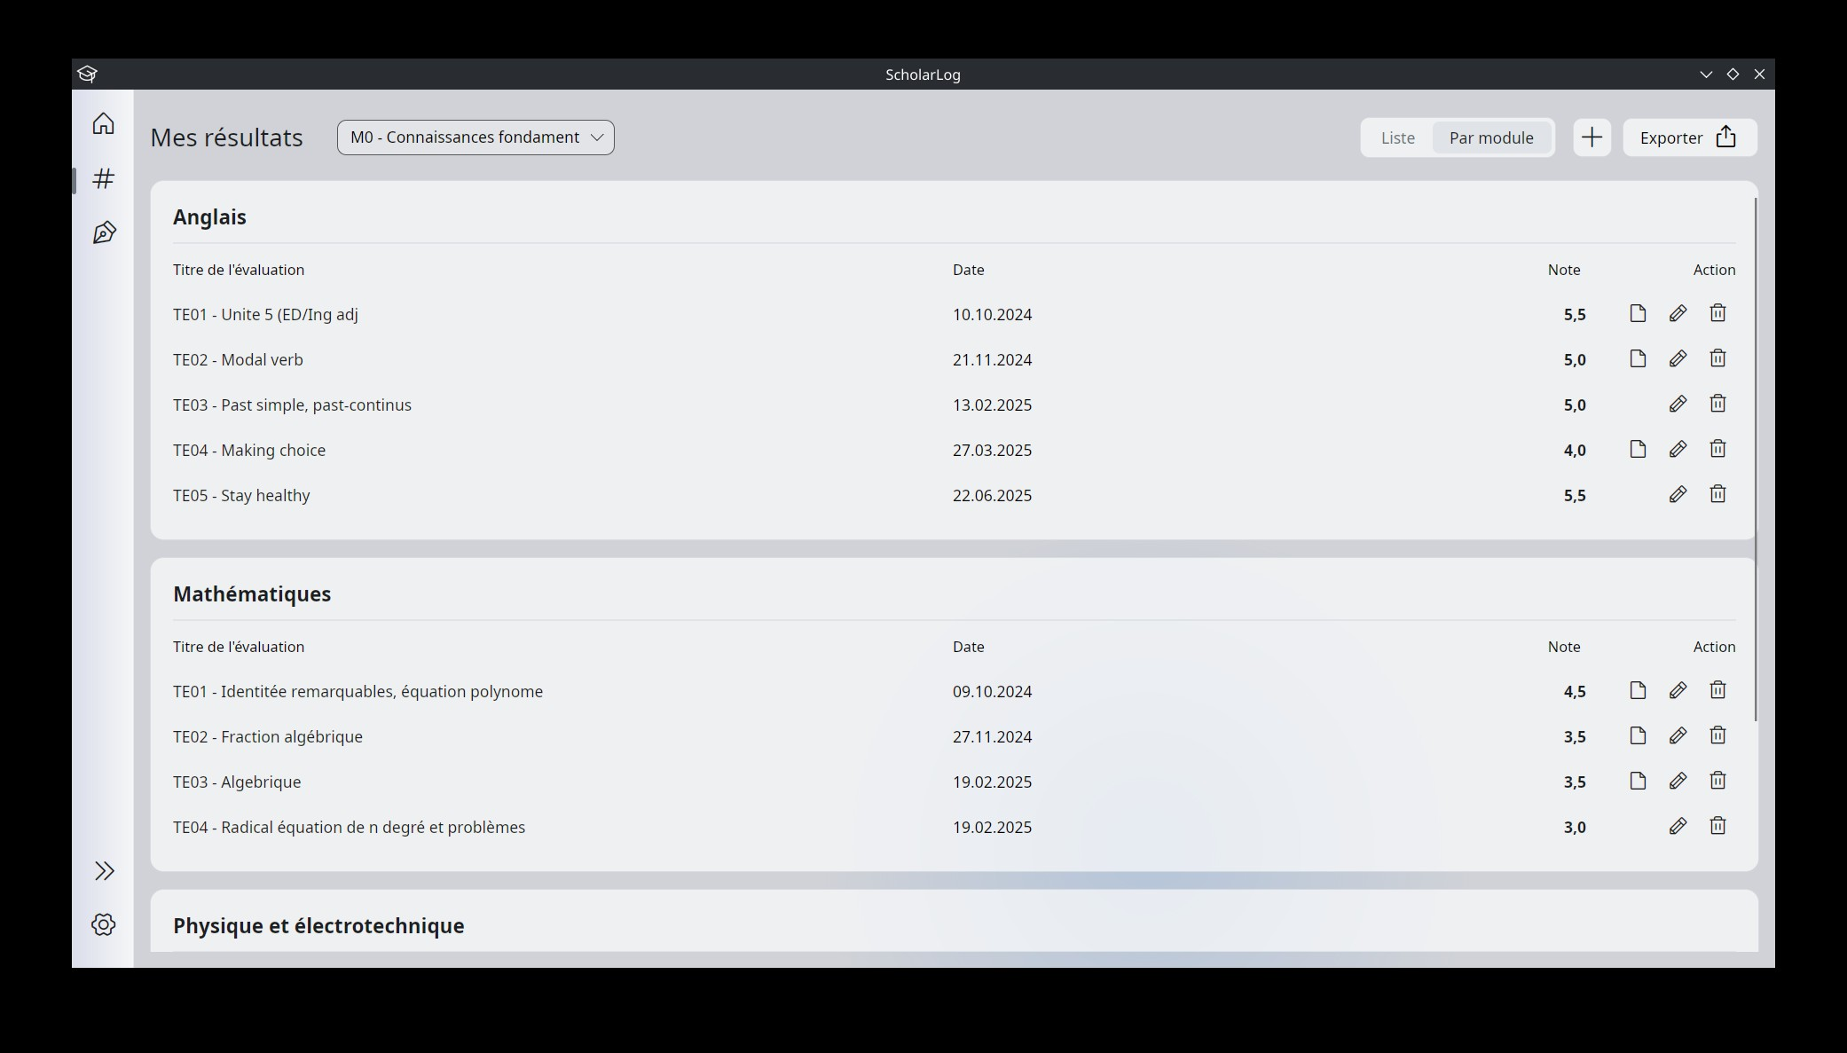
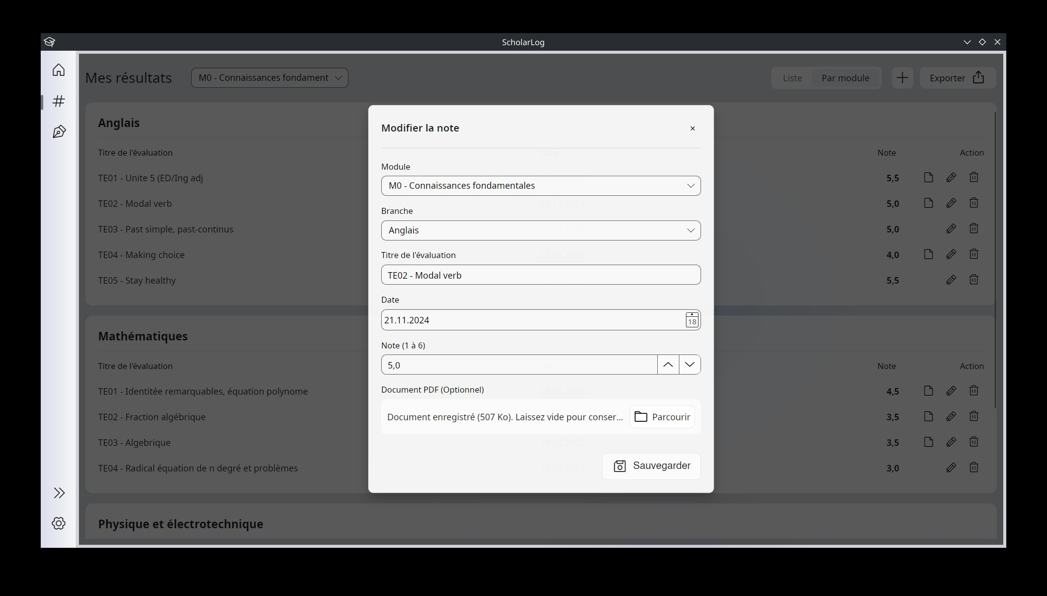
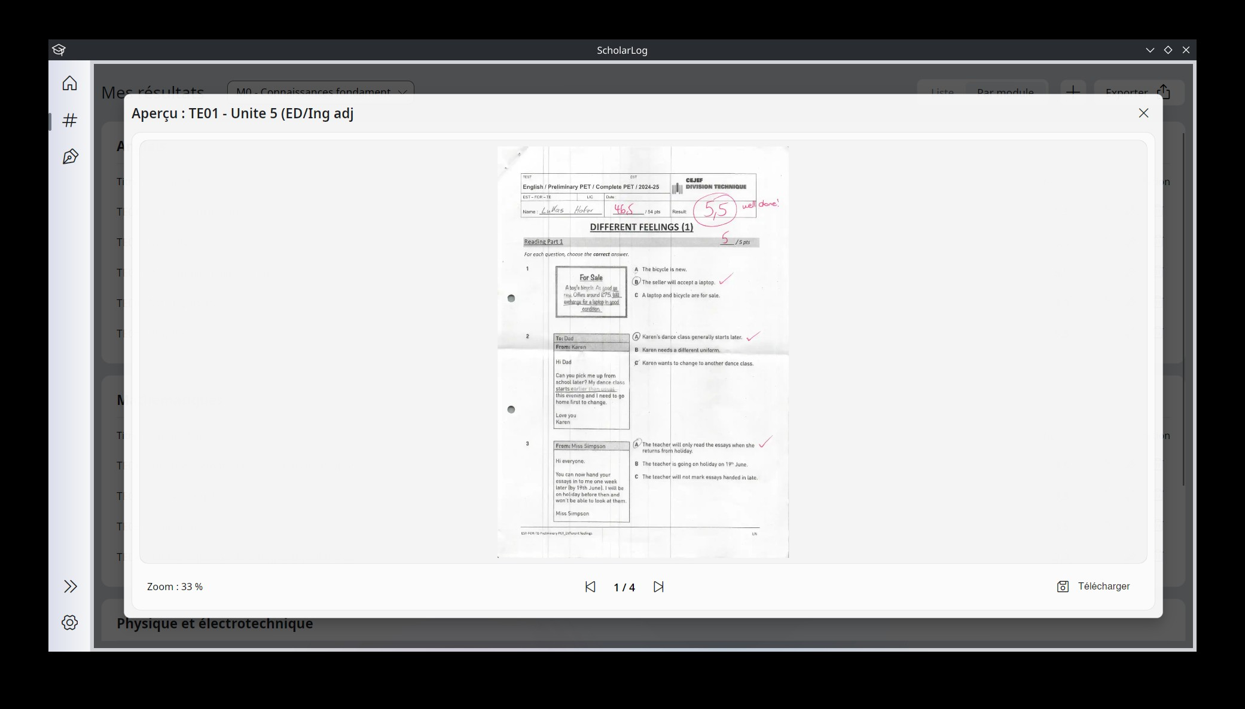

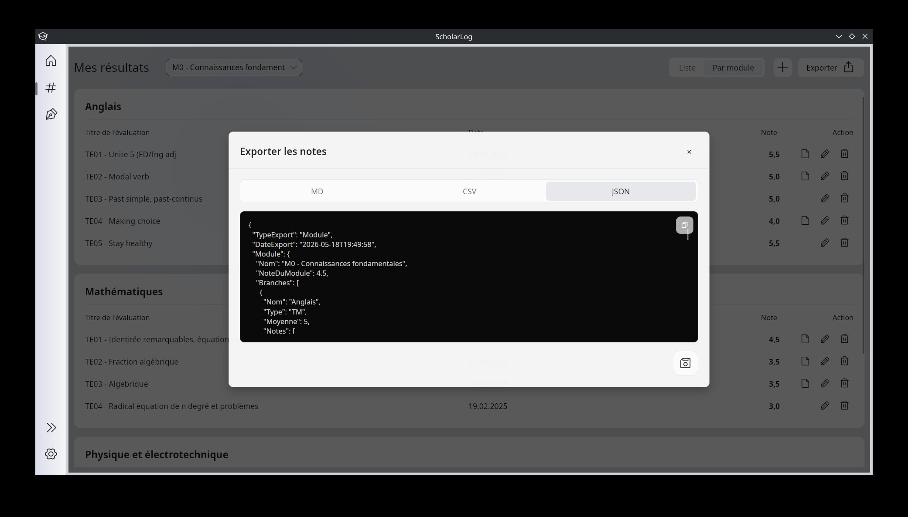

3.3 The Journals Menu (My Journals)
The notebook icon in the sidebar gives you access to the "My Journals" page. This space is specifically designed to ensure rigorous tracking of the time you dedicate to your various learning modules.
- Module Selection and Global View :
At the top left, a dropdown menu allows you to select the module for which you want to view or enter hours (e.g., M5 - Génie logiciel). The main table then displays all your work sessions, including the date, time spent, type of work, and a detailed description of the completed task. The total time invested in this module is displayed in the top right corner.
- Add, Edit, or Delete an Entry :
To log a new work session, click the + button. The "Nouvelle entrée" (New entry) window will ask you to enter the date, duration in hours, type of work, and a short description.
  - As with the grades, you can use the Pencil (edit) and Trash bin (delete) icons in the "Action" column to manage your existing entries.
- Manage Categories (Work Types) :
To organize your tracking in a personalized way, click the gear icon (next to the total hours). The "Gérer les catégories" (Manage categories) window will open. Here, you can create new categories (e.g., Programming, Research, Prototyping) or edit and delete existing ones.
- View Hours Distribution :
By clicking the pie chart icon (located between the gear and the + button), you open a visual analysis window. A donut chart shows you exactly how your total work time has been distributed among your different categories.
- Export Your Journals :
Just like your results, the "Exporter" (Export) button allows you to extract your work history. You can choose between MD (Markdown), CSV, or JSON formats, and then copy the text or save it directly to a file on your computer.

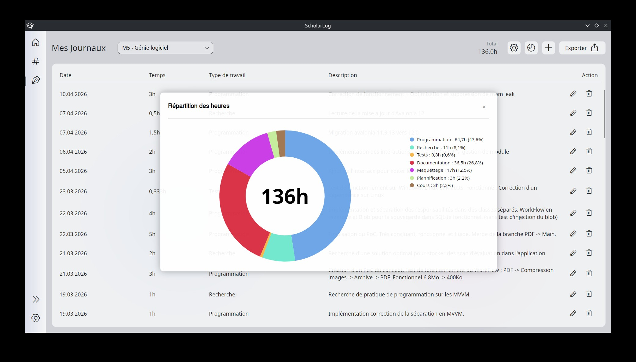
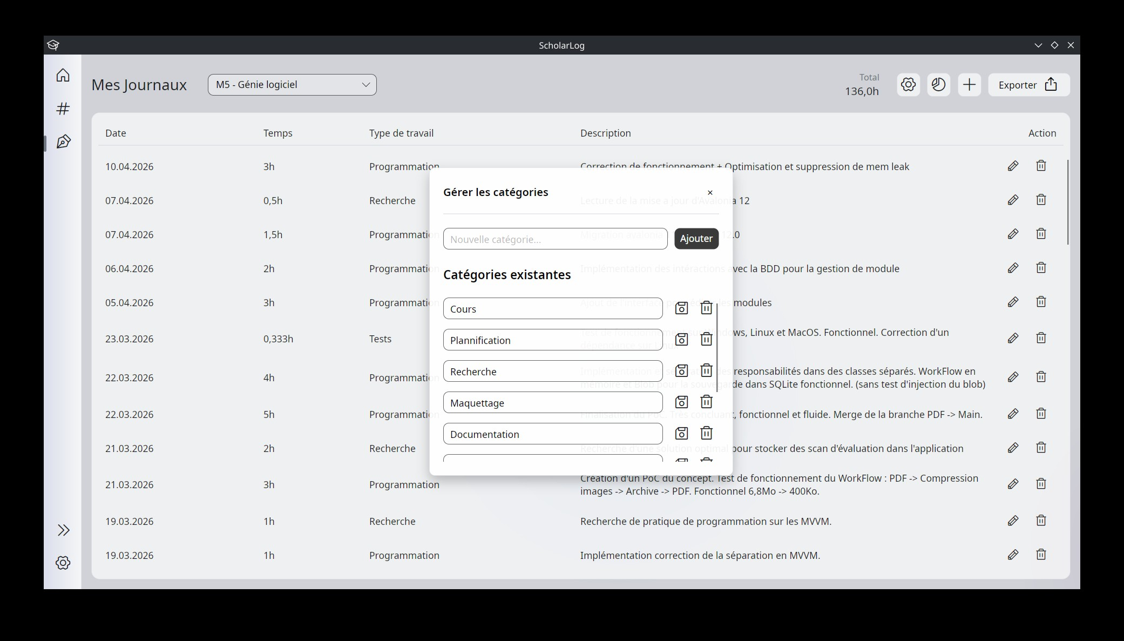
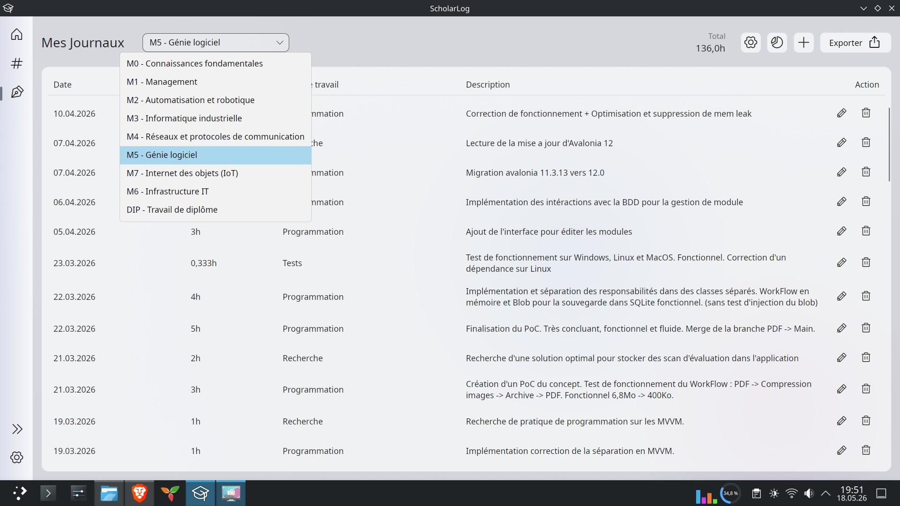
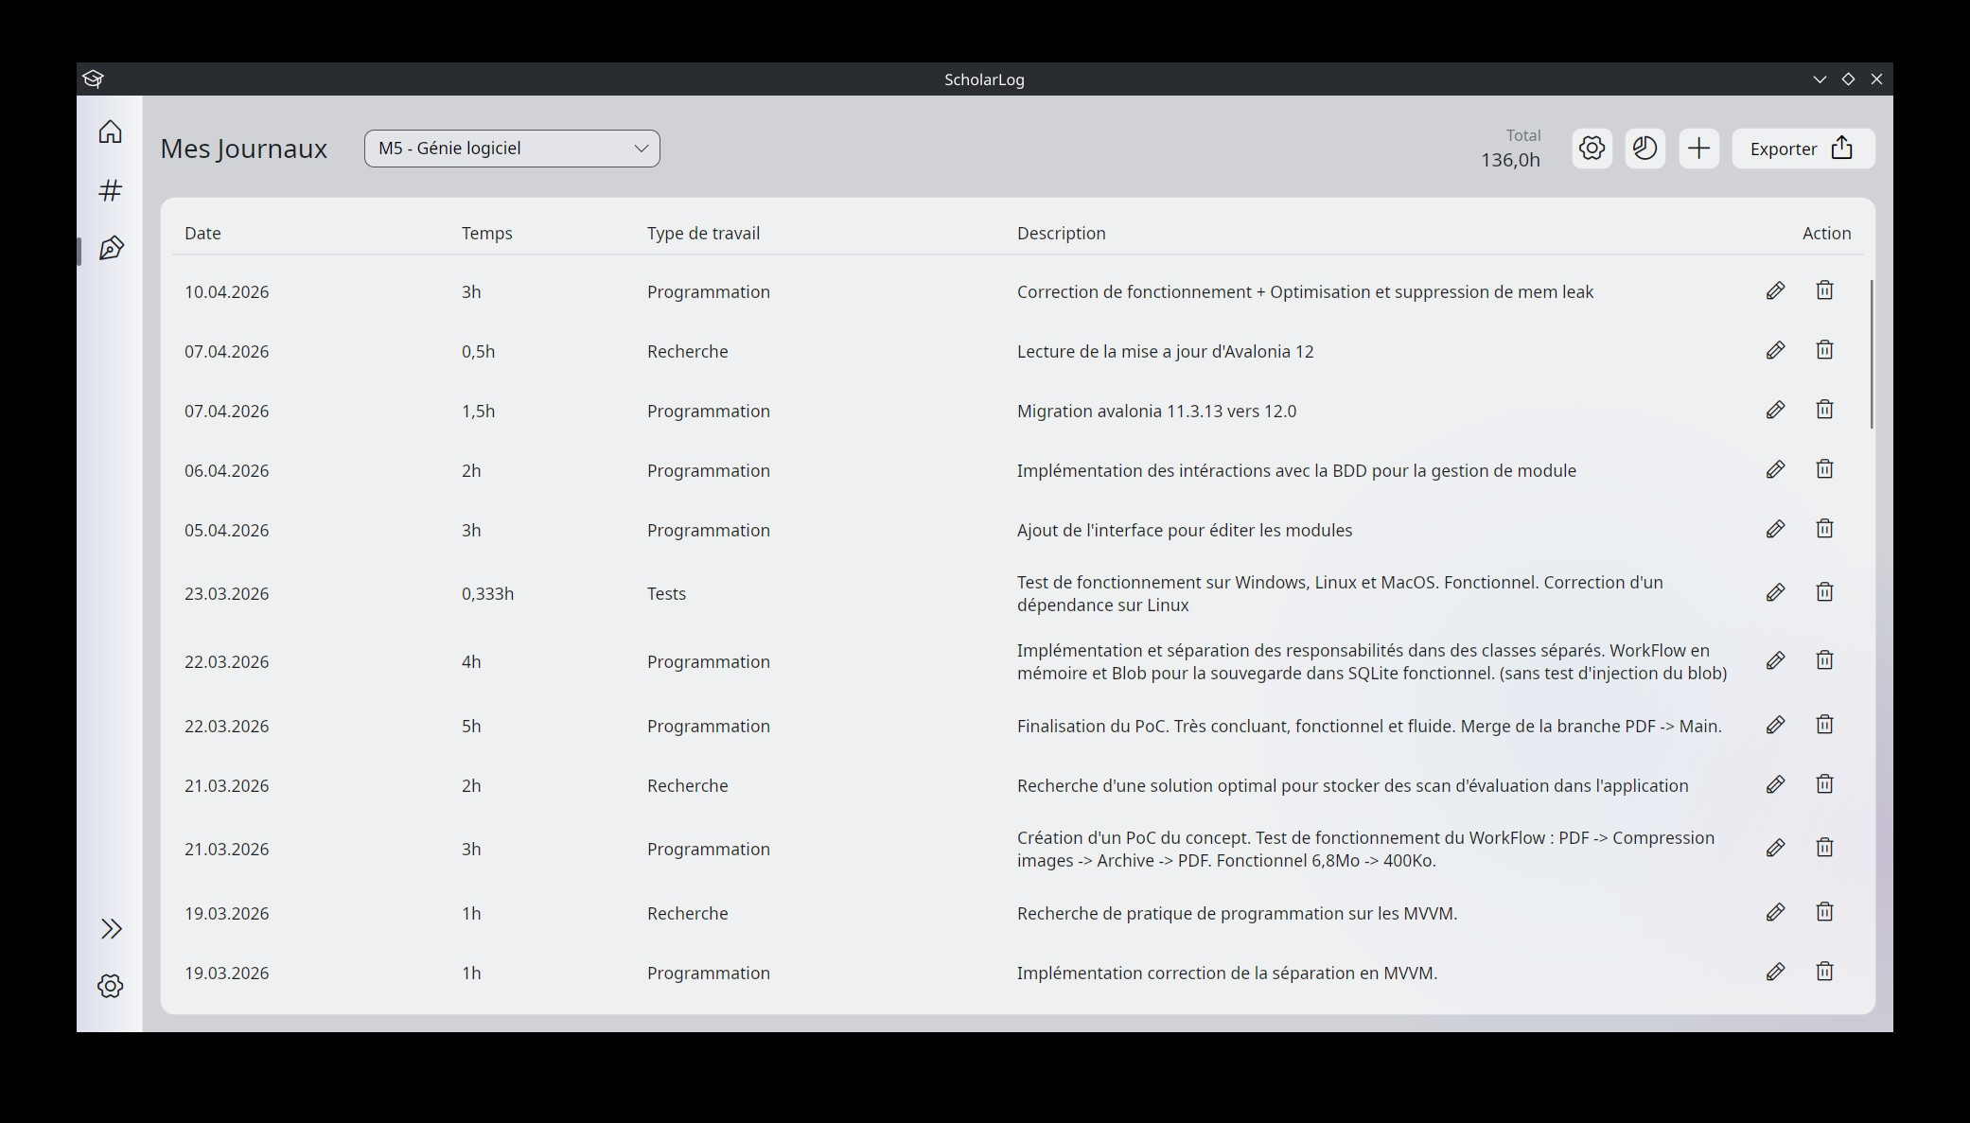

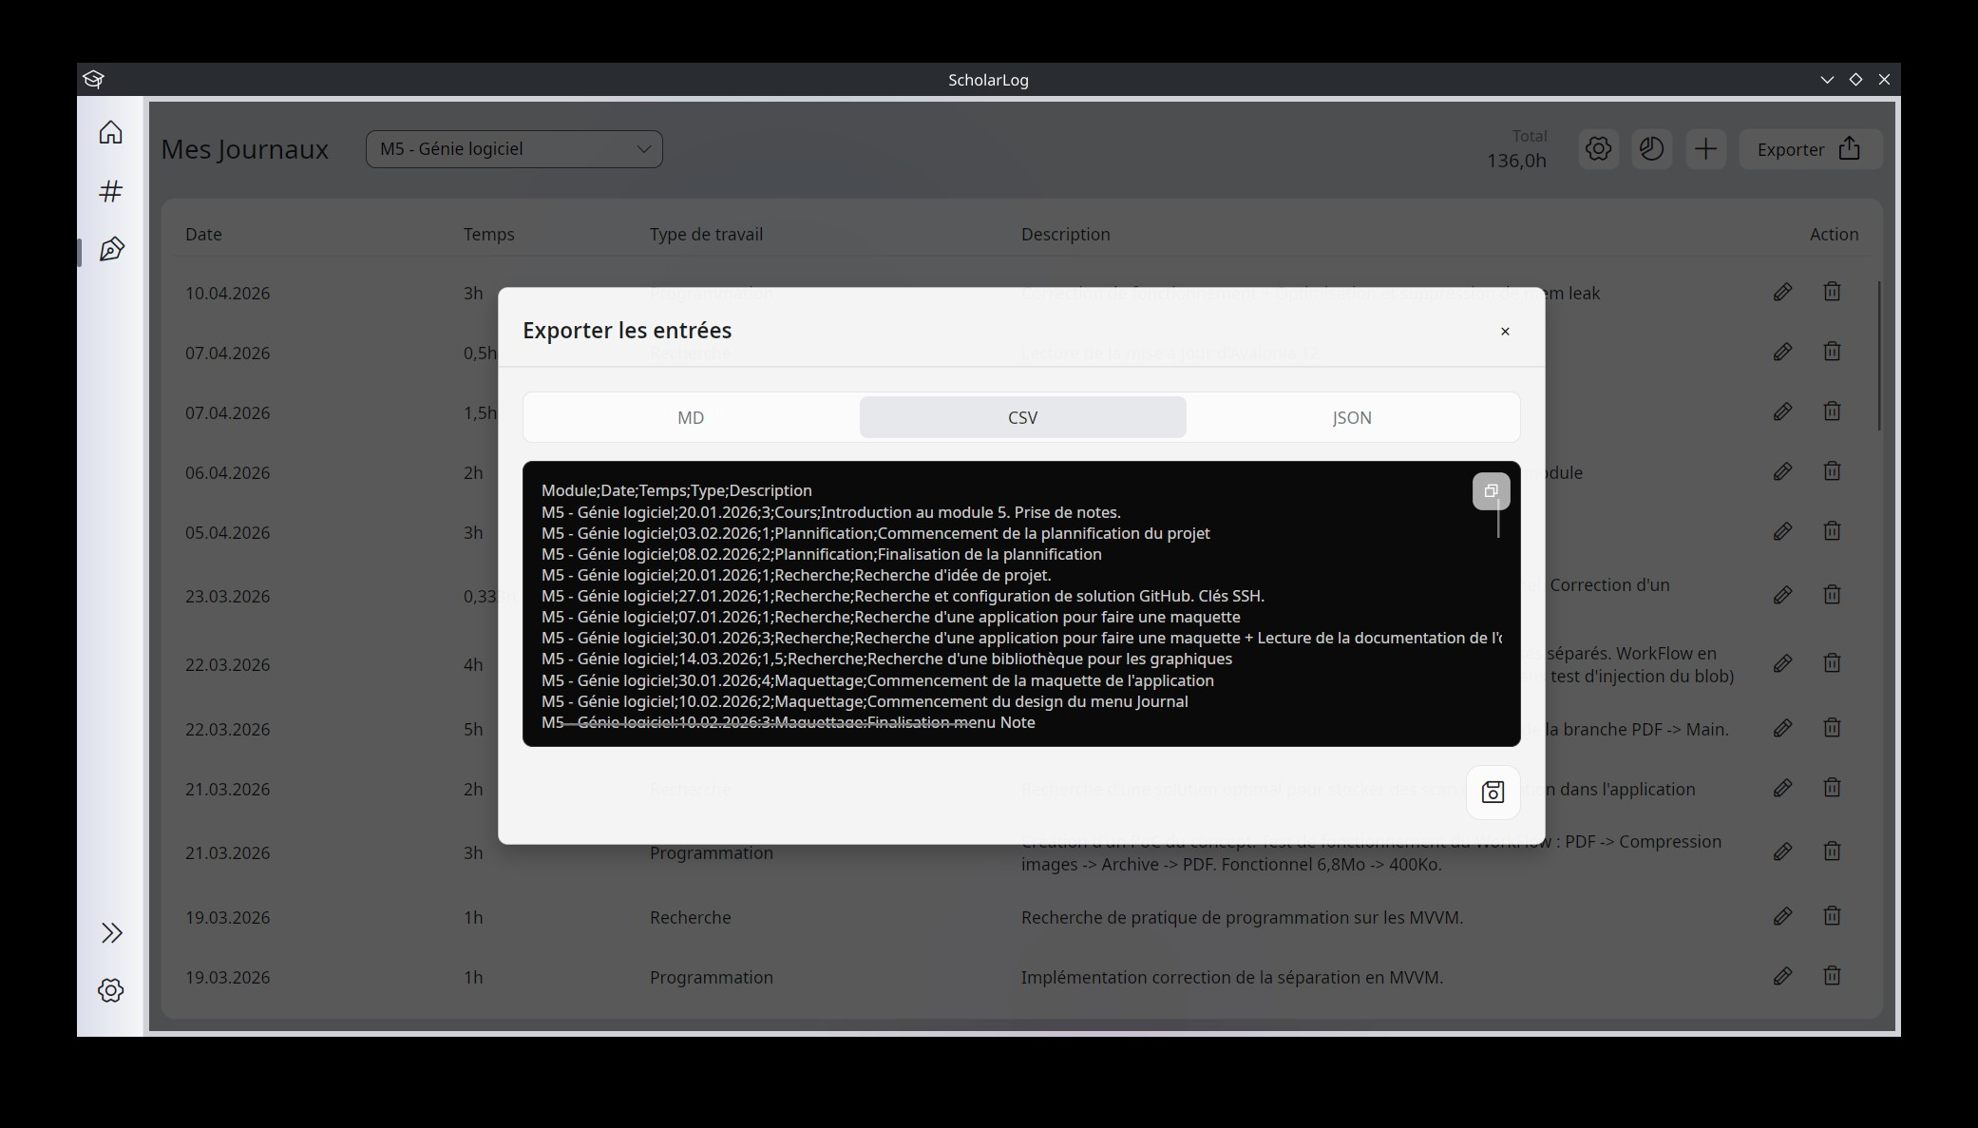
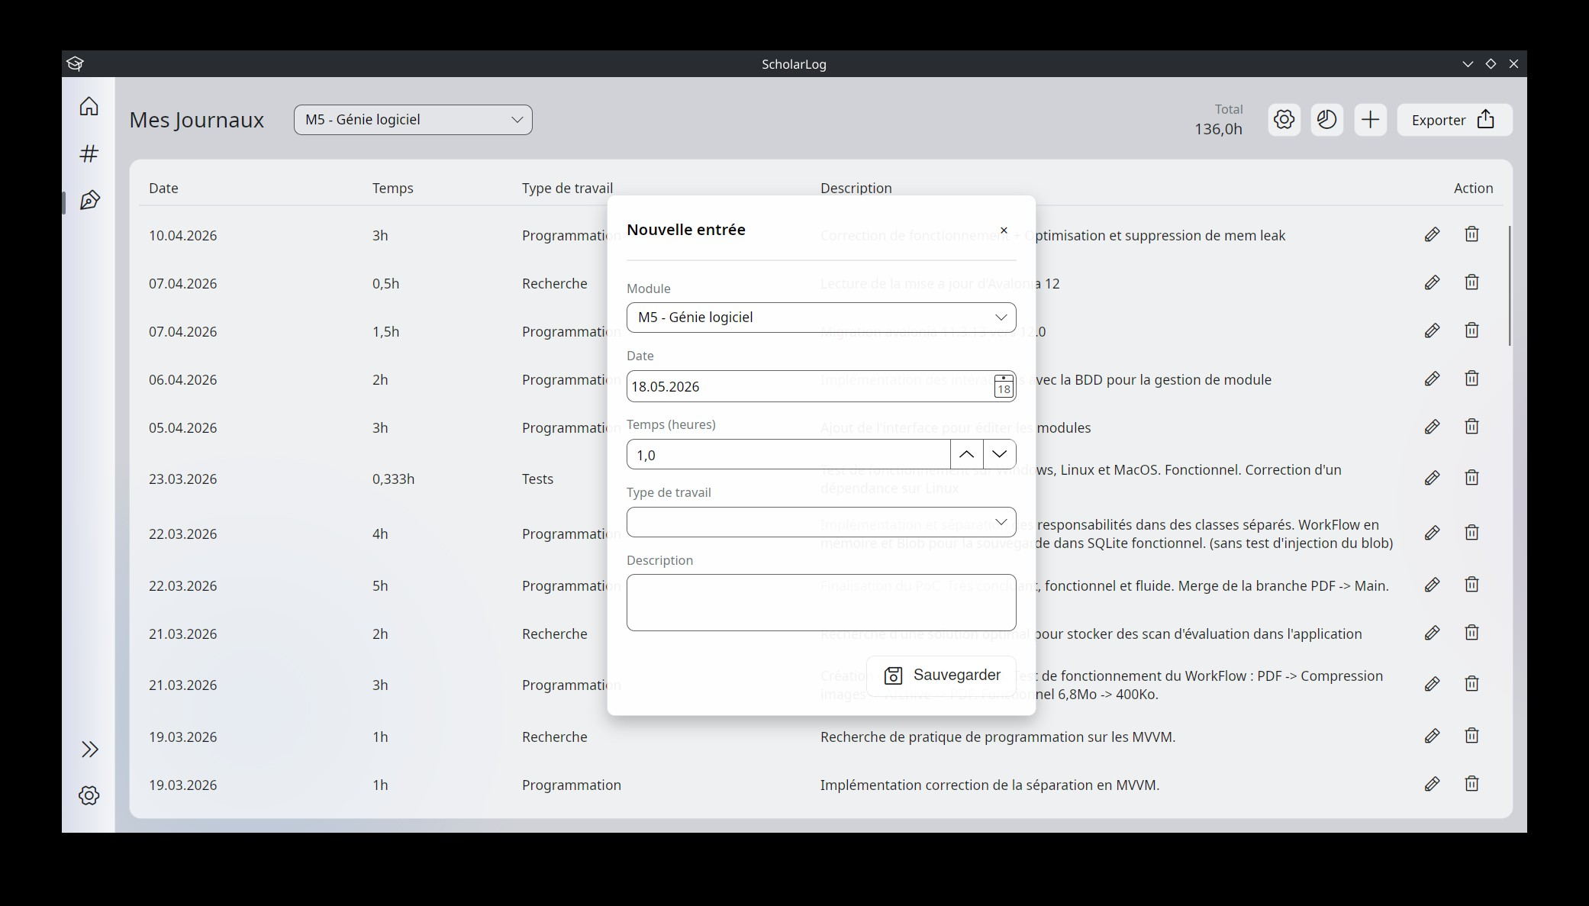

3.4 The Settings Menu (Paramètres)
The gear icon at the bottom of the sidebar opens the "Settings" page. This is the application's control center, where you can configure technical aspects and structure your educational layout.
General Configuration (Top of the page) :
- Database (Base de données) :
Since the application runs locally, your data is stored in a single file (SQLite). This section allows you to view and change the location of this backup file (.db) on your computer using the "Parcourir" (Browse) button.
- Performance (Performances) :
A toggle switch allows you to disable visual effects. This is useful if you want to reduce the application's resource consumption on a less powerful computer.
- Appearance (Apparence) :
Although the application can adapt to your system, this switch allows you to manually force the toggle between light mode (sun icon) and dark mode (moon icon).
Course Management (Modules and Branches) :
The lower part of the screen allows you to completely organize your learning environment.
- Overview :
Your modules (M0, M1, M4, etc.) are displayed as cards. Each card summarizes the module's content and displays its associated subjects (branches).
- Add a module :
By scrolling to the very bottom of the page, you will find a special "+ Ajouter un module" (+ Add a module) card to create a new main teaching block.
- Edit an existing module :
Clicking the Pencil icon on a module opens an "Éditer le module" (Edit module) window. From this window, you can :
  - Rename the module and save it using the floppy disk icon.
  - Create a new subject by typing its name and clicking "Ajouter" (Add).
  - Manage "Branches existantes" (Existing subjects) by renaming or deleting them using the Trash bin icon.
- Delete a module :
The Trash bin icon located directly on the module card allows you to permanently delete it from your layout.

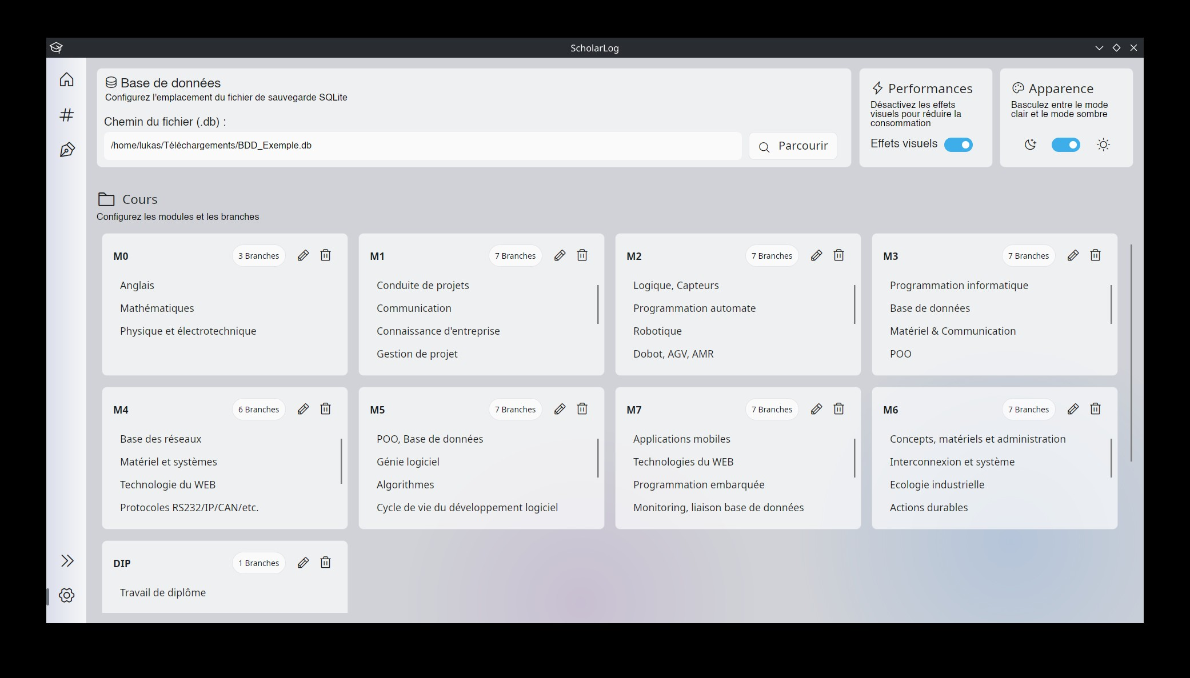
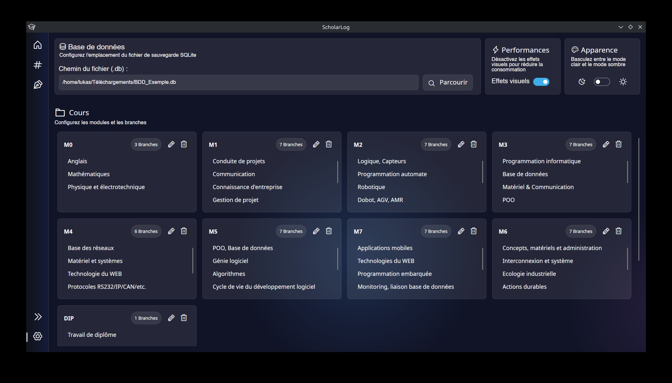

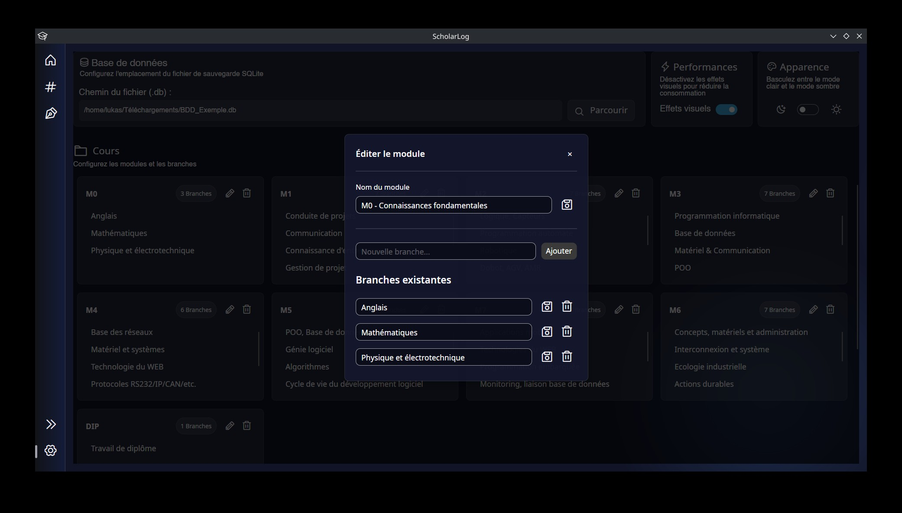

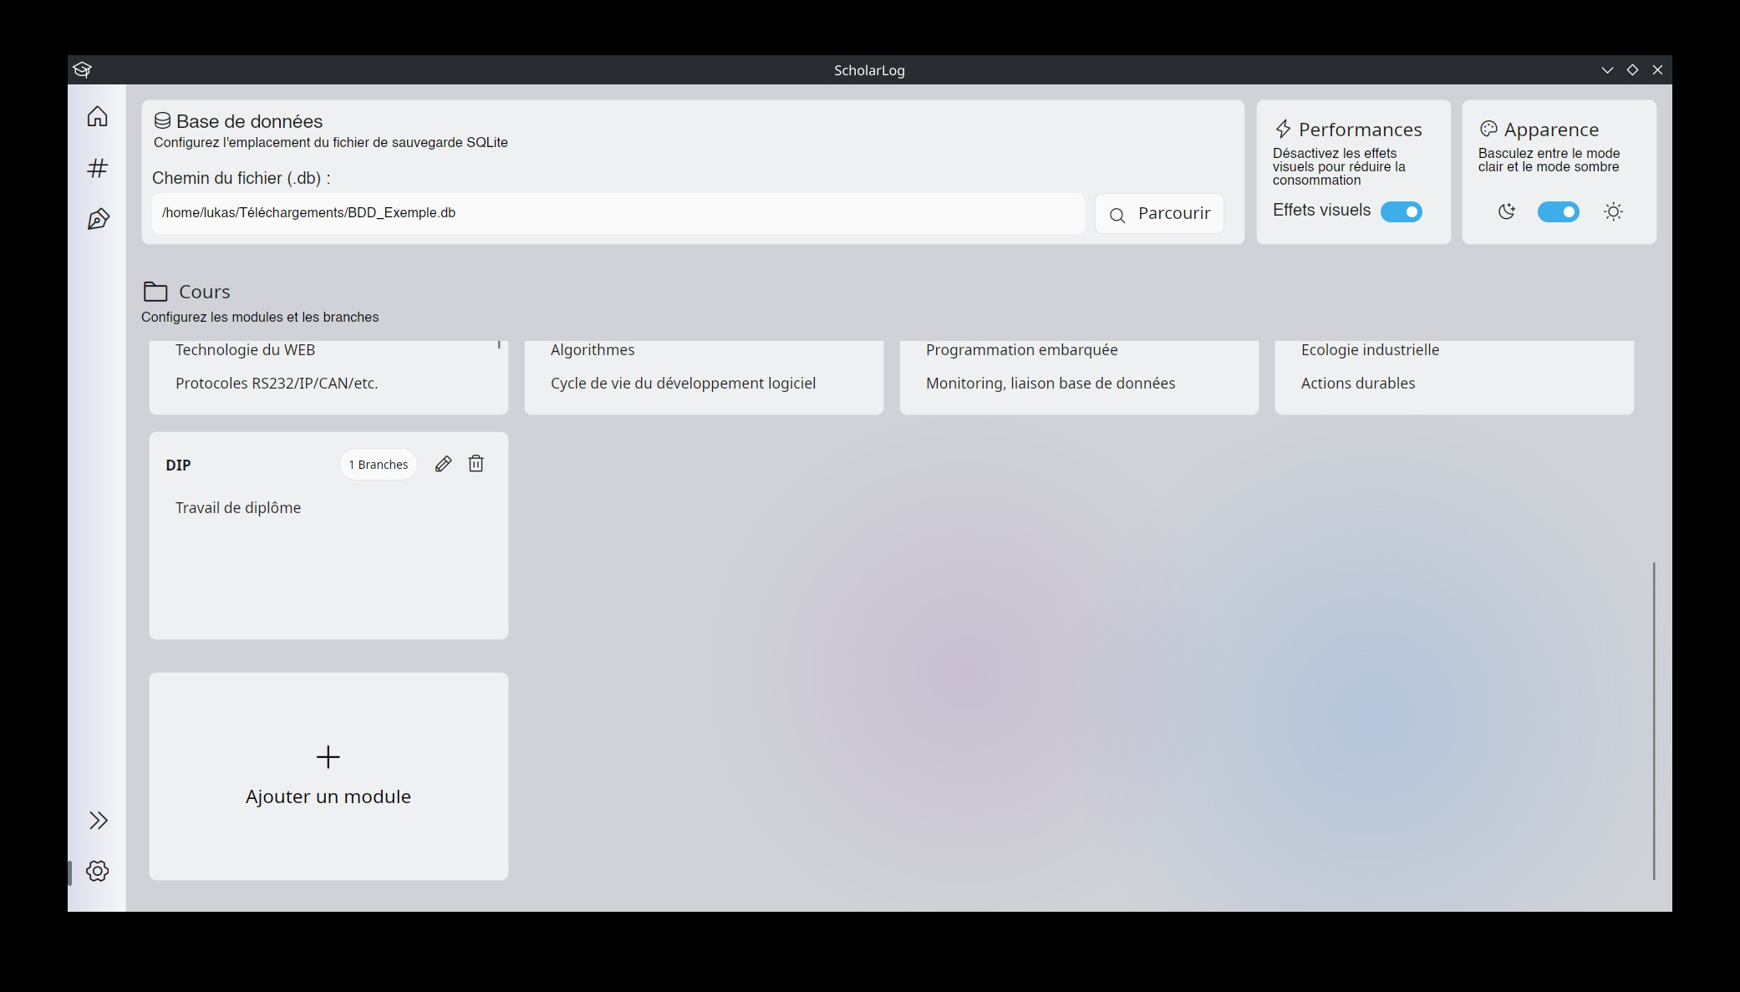
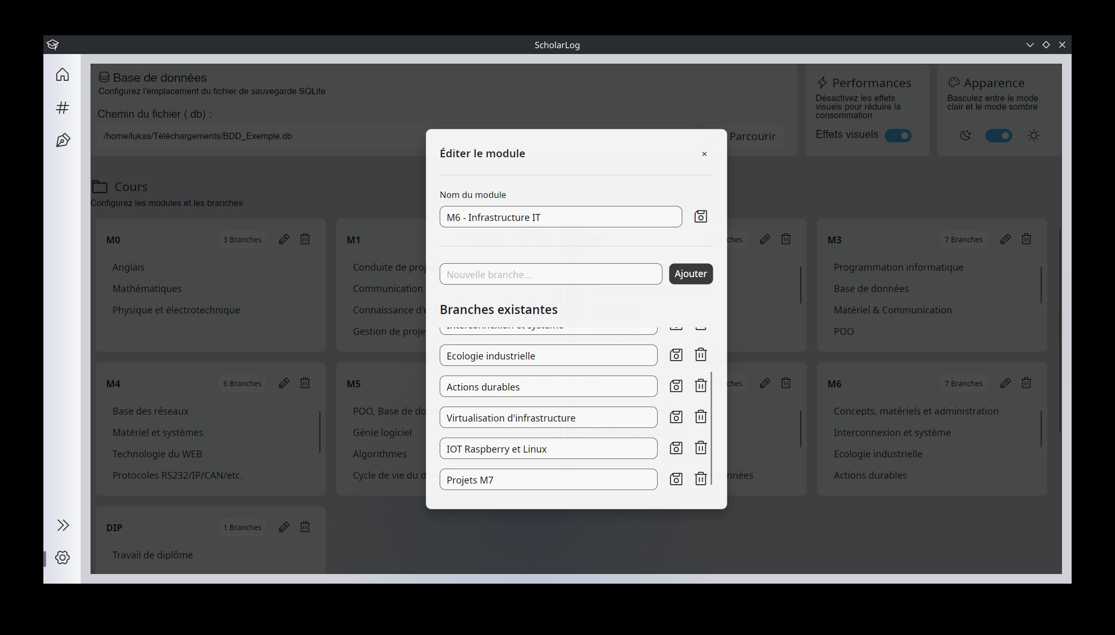

4. Average Calculation Logic
One of ScholarLog's core strengths is automating your academic tracking. To perfectly align with the École Supérieure Technique's grading standards, the application applies a strict mathematical rule in the background :
- Automatic Rounding :
All arithmetic averages calculated by the system (whether for a specific subject or a global module) are systematically rounded to the nearest half-point (0.5).
- Trend Indicators :
The trend arrows (up, down, stable) displayed on your dashboard compare your latest grade with your overall average, applying a tolerance margin of 0.2.
These rules ensure that the results displayed on your dashboard accurately reflect your official report card.

5. Limitations regarding attached PDF files
To ensure optimal performance and save storage space on your computer, ScholarLog smartly compresses the PDF documents attached to your results. This method involves two limitations that you should be aware of :
- Loss of text selection :
PDF documents are converted into images upon import. Therefore, it is no longer possible to select or copy text with your mouse within the application.
- Alteration upon export :
If you download a previously saved document, the retrieved file will not be the original source PDF. It will be a scanned and compressed version of it.

6. Data Backup and Security
ScholarLog was designed to guarantee your privacy and autonomy. Therefore, the application operates entirely locally and independently.
- No Cloud Synchronization :
Your data does not pass through any remote server, and there is no automatic cloud backup.
- Single File :
All of your information (grades, journals, settings) is stored in a single database file (.db) on your computer.
- Backup Responsibility :
Your data is valuable. It is your responsibility to create regular backup copies of this .db file (the location of which can be configured in the Settings menu) to an external drive, such as a USB flash drive, or your personal cloud storage, to prevent any loss in the event of a hardware failure.

7. Software License (GPLv3-only)
The ScholarLog application is free software distributed exclusively under the terms of the GNU General Public License v3.0 only (GPLv3-only).
As a user, this license guarantees your fundamental rights while protecting the project's open-source and collaborative spirit :
- Freedom of Use :
You have the right to run and use ScholarLog for any purpose, completely free of charge and without any restrictions.
- Access and Modification of Code :
You have full access to the application's source code. You have the right to study, analyze, and modify it to adapt it to your own needs as a student or developer.
- Sharing and Redistribution :
You are permitted and encouraged to redistribute exact copies of the software to your peers or other students.
- Reciprocity Obligation (Strict Copyleft) :
If you modify ScholarLog's code and choose to distribute your modified version, you are legally required to share it under the exact same license (GPLv3) and make your source code publicly available.
The "GPLv3-only" Clause: This technical clause specifies that the permissions granted apply strictly under the terms of version 3 of the GPL.
Unlike some other projects, there is no automatic upgrade to potential future versions of the license (such as a hypothetical GPLv4), which permanently anchors the project's legal governance to this specific version.

